How quickly will I be able to see changes to my timetable?

Changes to your personalised timetable will typically appear in your online timetable within 15 minutes.

You will also receive an email notification about any change to the date, time or location of an activity in your personalised timetable.

It can take up to 24 hours before changes are visible in your connected calendar application.

How can I contact students about an activity?

Staff can use the Email students option in the activity dialogue. When you click this button, the system generates a list of the students attending that activity and their email addresses.

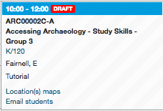

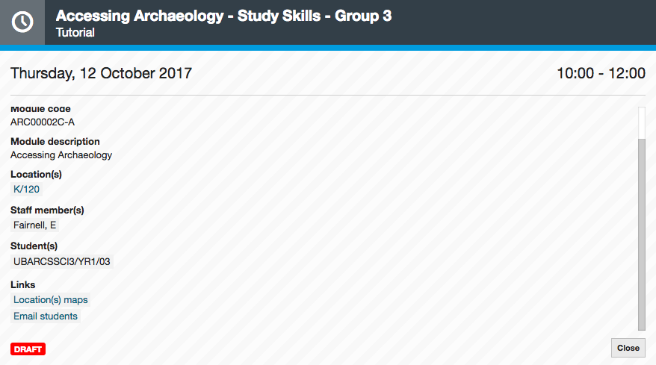

How do I view any clashes in my timetable?

In Week view, clashing activities are displayed side-by-side, indicating that they are taking place at the same time.

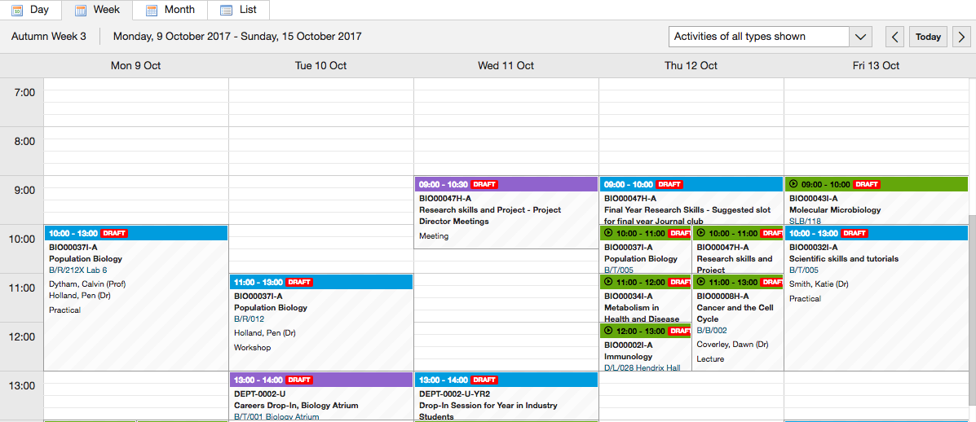

In List view, you can use the setting Highlight clashing activities, which highlights clashing activities in yellow.

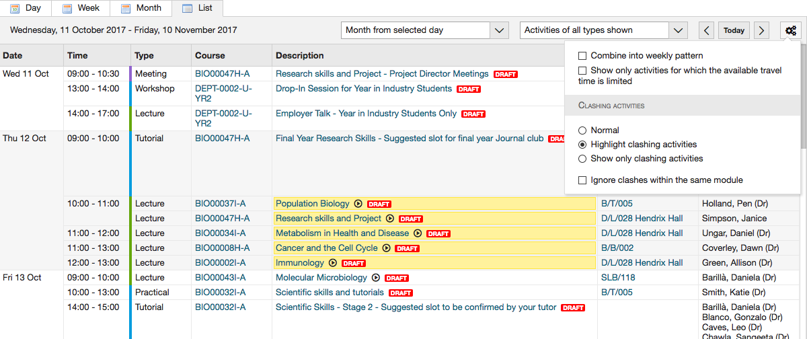

You can also use the setting Show only clashing activities.

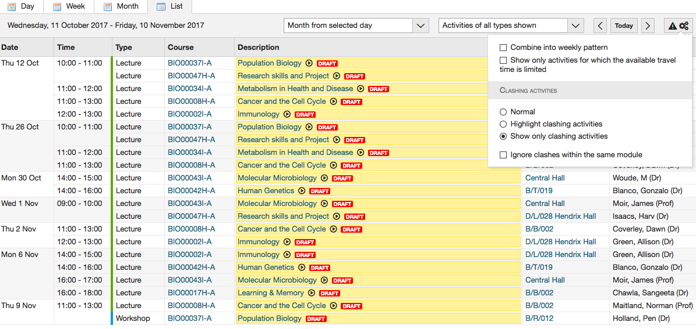

How can I view any travel warnings in my timetable?

If your timetable includes two activities taking place on different campuses with limited travel time (fewer than 30 minutes), the system will give you a warning.

The warning symbol is a walking figure in a yellow box and is visible in all views of the timetable.

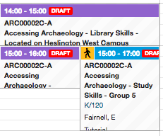
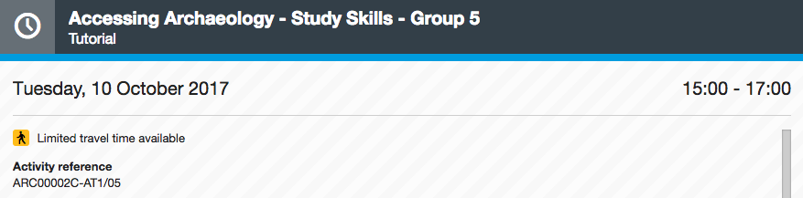

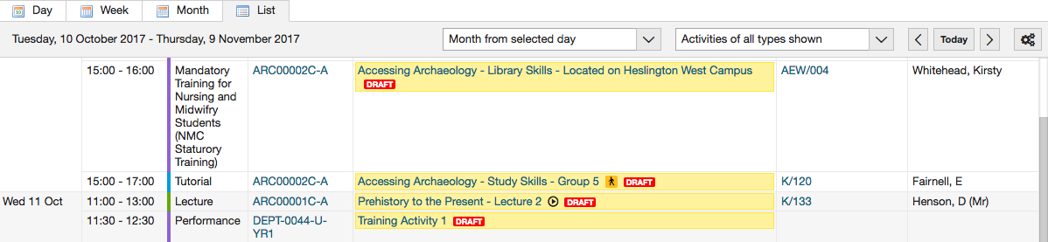

How do I know if an activity will be recorded?

Activities that will be recorded have a symbol, which is visible in all views of the timetable. This indicates that a recording of the activity will be made available through the VLE.

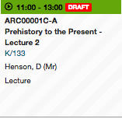

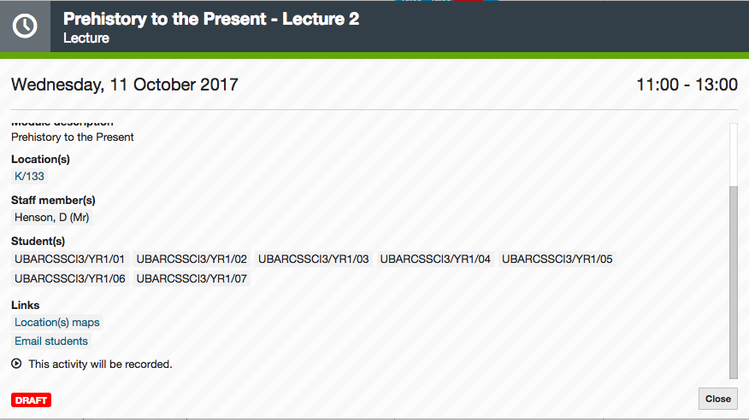

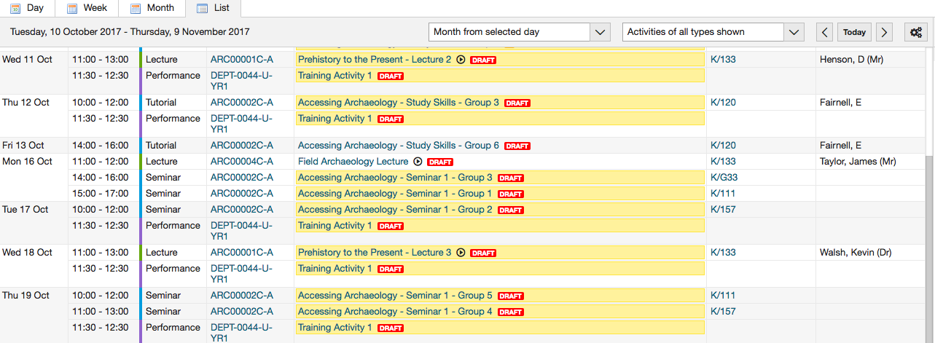

What do the different colours in my timetable mean?

Activities in your timetable are colour-coded by type. Here’s a quick guide:

- Green is a lecture or film screening
- Blue is a seminar, supervision or tutorial
- Orange is a workshop, group project or problem class
- Vivid orange is a field trip or practical
- Pink is a presentation, feedback session or rehearsal
- Red is an assessment, induction activity, mandatory training or performance
- Purple is a meeting
- Cyan is a masterclass or placement
- Dark grey is a careers event or optional activity

How can I check an academic staff member’s availability?

We advise you to check a staff member’s availability in Google Calendar, as this should include both their timetable and their meetings and appointments.

You can use the Add timetable function in the online timetable to look at a staff member’s teaching timetable. But remember that this does not include their meetings and appointments.

How can I find out how to get to a location?

Each activity has a link to a campus map and to the University’s audio-visual pages, where you can find directions and other information about the location.

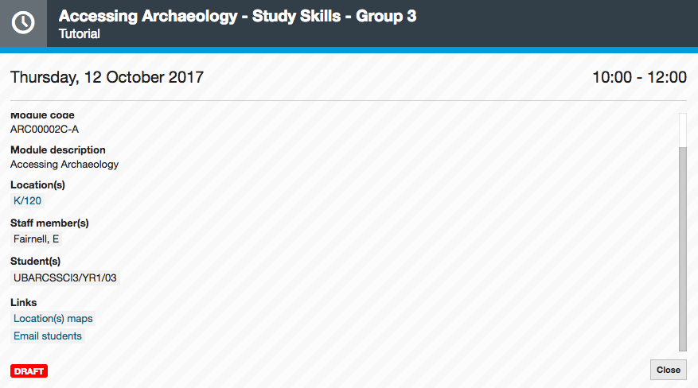

Can I book a room using the online timetable system?

All room bookings should be made in Planon, which will also show you the most up-to-date room availability on campus.

You can use the Location view in the online timetable to view what’s going on in a certain room or building. This view includes both timetabled activities and room bookings. Be aware that this view can take 1-2 hours to update with the latest room bookings from Planon.

